

Barnum Elementary

BES BOMBER NEWS

October 2018



## From the Principal

It’s hard to believe the first month of school is in our rearview mirror. September is a month filled with excitement and anticipation of the year ahead. As we roll into October, routines have been established and we are digging into learning. Here at BES, we take pride in our work with students and strive to provide the best learning environment for everyone. As caregivers and parents, you are part of our equation as well. We value your support and feedback as we positively problem solve situations that come our way in the day to day business of working with kids. When these events occur, conversations with teachers or the team involved is the most effective way to improve outcomes for our kids. We value positive communication and encourage you to reach out to us.

October is before us, and that means Homecoming week, ELC, Halloween, and more. Be sure to peek inside for more details.

In partnership,

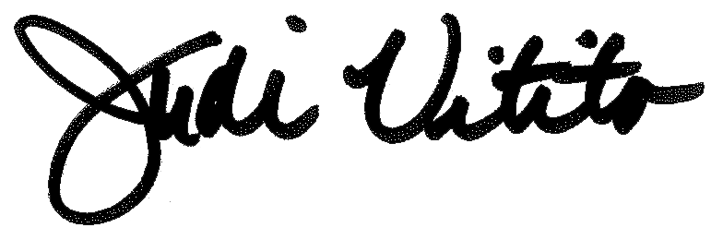

Judi Vitito, BES Principal

* Counselor’s Corner
* Upcoming Dates
* PTO information

Inside

A Lifelong Celebration of Learning!

School

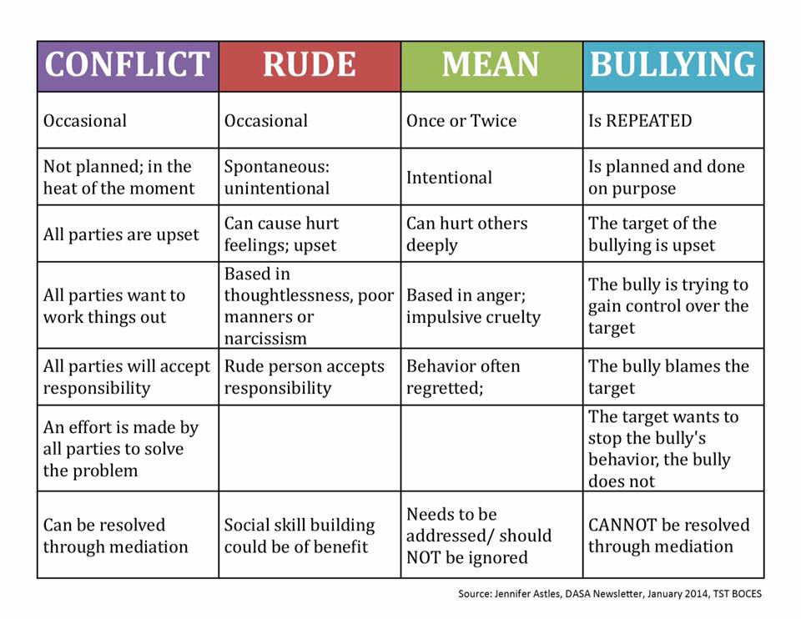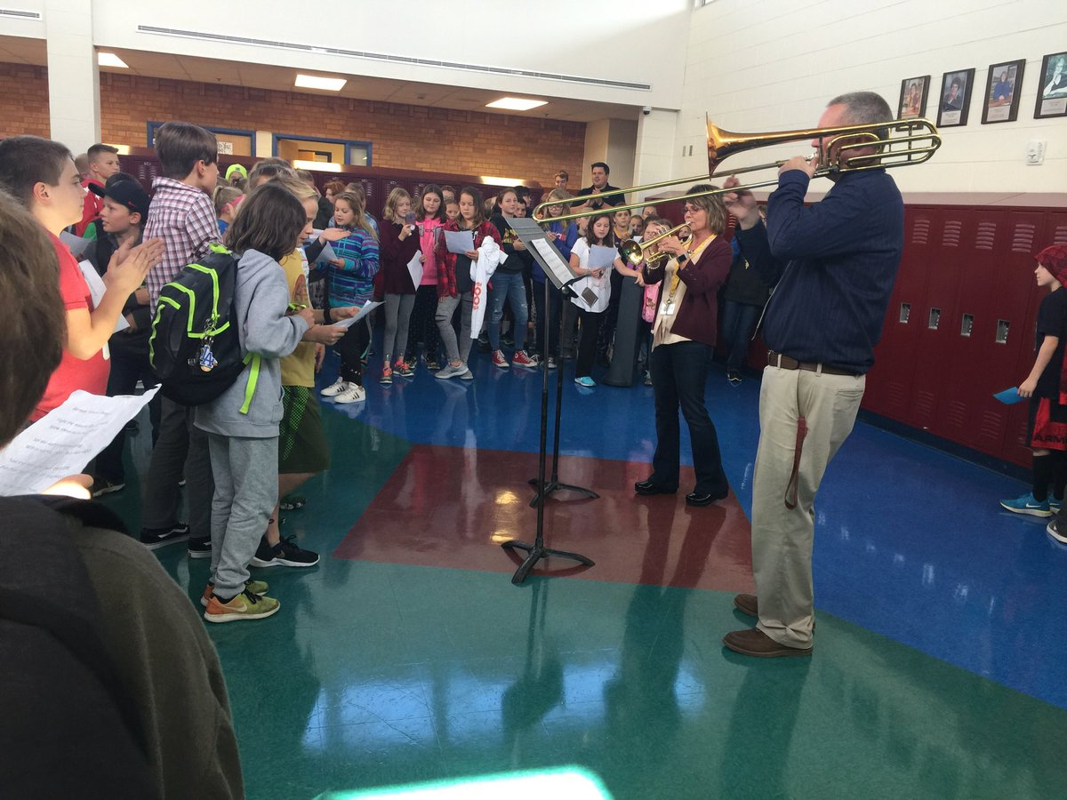

Kindness

Counts!



**Why I am Focusing on Pro-Kindness for Anti-Bullying Month**

**Mrs. Kresky**

**BES School Counselor**

Meanness can be common among kids. Just like it can be common among adults. They argue, complain, accuse, gossip and exclude. I'm not defending or excusing anything about this behavior. Obviously, we need to encourage all kids to be kind, caring individuals. But, given that we adults haven't managed to achieve world peace or perfect relationships, we also need to recognize that learning to be kind, especially when we're upset or hurt, is hard. It takes a lot of effort, time and practice.

This year at Barnum Elementary, we are really focusing on putting in that extra time and effort to give our students the tools they need to work through their problems in effective ways. We are teaching our students that the moment they walk through our doors one of their most important jobs is to look out for, and support one another.

We are also teaching them about empowerment. Especially during moments when they may be feeling upset or even feeling like they are being bullied. Nowadays, everything from "Joe said I was being annoying," to, "Sue rolled her eyes at me" is being called bullying. And that is where we have missed the mark. It is our job to teach our students about when it really is bullying and when it is just a conflict, rude, or mean behavior. More importantly, we need to teach the "bullies", how to truly understand the way their actions have impacted and hurt their victim because saying, "I'm sorry" isn't enough.

Pro-Kindness is my focus. The last time I checked, no one has ever felt bad about doing something kind for someone else. If at the end of the day, our students can say to themselves, "Yes, I was kind today,” in some way, shape or form.Then they should be able to go home feeling happy, which is our ultimate goal here at BES.

### Counselor’s Corner

**FROM OUR PTO**

**Fall Fundraiser**

We will kick off the annual fall fundraiser on Friday, October 8th. All proceeds support various programs in our schools. Some examples include field trips, open house, all school t-shirts, book fairs, and more. The fundraising efforts will conclude on October 22nd and a celebration assembly in November. This year, when students reach our school goal, names will be entered in a drawing for a chance to SLIME the PRINCIPAL. Thank you in advance for supporting these efforts.

**Box Tops**

Box Tops can be brought to school at anytime throughout the year. PTO will be sponsoring a Box Tops contest from October 8th-26th. The classroom with the most Box Tops will earn an extra something special. ☺

**Meetings**

PTO meetings are held on the first Monday of each month in the BES media center from 6:00-7:00. Childcare is provided and we welcome you to the group! Check out the PTO website [www.barnumpto.org](http://www.barnumpto.org) or facebook page, Barnum PTO, for more information.

**Vision and Hearing Screening** was done on Friday, September 21st. The following grade levels were screened:

Kindergarten – hearing

1st grade –vision/hearing color vision (boys only)

2nd grade – hearing

3rd grade – vision/hearing

5th grade – vision/hearing

Students newly enrolled at Barnum – vision/hearing

Students who did not pass their vision or hearing will be re-screened 1-3 weeks following the initial screening. If they do not pass the re-screening, a referral letter will be sent out to the parents recommending follow-up care by your health care provider.

*Thank You to the parents who volunteered their time to screen our students!! We appreciate your help!*

**UPCOMING EVENTS** – be sure to mark your calendars:

**October 5th** – PLC day; no school

**October 12th** – Grandparent’s Day @1:00

**October 15-17** – 6th grade to Wolf Ridge

**October 17-19** – Teacher workshop/MEA Break; No school

**October 24th** – Picture RETAKE day

**October 24th** – Public Health Flu Shot Clinic – High School Commons – 3:30-6:00 pm

**November 5th-** Teacher Inservice

**November 13th & 15th** – Conferences

**November 22 & 23** – Thanksgiving Break; No school

**December 7th** – Teacher PLC day; No school

**December 20th** – Holiday Program @6:00pm at BHS