

Barnum Elementary

BES BOMBER NEWS

November 2018



Fire safety week. Homecoming. Choose Respect over Bullying Week. Halloween. Countless other activities have filled our October calendars, and now we are moving onto November. A few cold weather reminders…

Is your child missing a sweatshirt? Jacket? Mittens? Other items? Check out our lost and found in the cafeteria. It’s overflowing with clothing that is looking for its home!

Now that colder weather is settling in for the season, please remind your student(s) to have warm gear for outside play. As a proud, hearty Minnesotan crew, we enjoy outdoor play in most weather.

In partnership,



Judi Vitito, BES Principal

## From the Principal

* Counselor’s Corner
* Upcoming Dates
* PTO information
* Health Updates

Inside

A Lifelong Celebration of Learning!

School

Counselor’s Corner

Mrs. Kresky

Upcoming Events

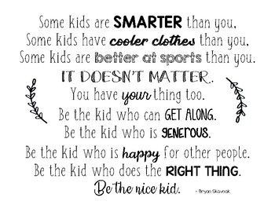

Mrs. Kresky

218-389-6976 Ext. 1135

nkresky@isd91.org

**Teaching Kindness Reduces Bullying**

Instead of teaching children what NOT to do, teaching them what they CAN do is important to create change. Teaching and encouraging kindness is related to many of the following positive outcomes:

* Happy children! There is a natural good feeling that results when we do an act of kindness, even if it’s small. Happy and compassionate children do not have a need to bully others.

* Higher self-esteem. The “helper’s high” that comes from endorphins in our brains when we do something kind increases our sense of belonging. Children will feel like they can have a true impact on their environment.
* More friends. Feeling like they are accepted and liked by peers is usually very important to children of all ages. Kindness increases our connections with other people on a deeper level.
* Better mental health. Acts of kindness increase serotonin levels, the natural brain chemical that improves mood. Have a consistently unhappy child? Encourage them to look outside themselves and be kind to someone else.

**Choose Respect over Bullying Week Was a Blast!**

We made a school-wide video. Had a door decorating contest. The high school drama club came down and gave a performance about bullying which we loved! And we did a school-wide unity project with the rocks from the rock garden in front of our school. We have become experts on what is, and what isn’t bullying; and what we can do if we are getting bullied or witness bullying happening to someone else.

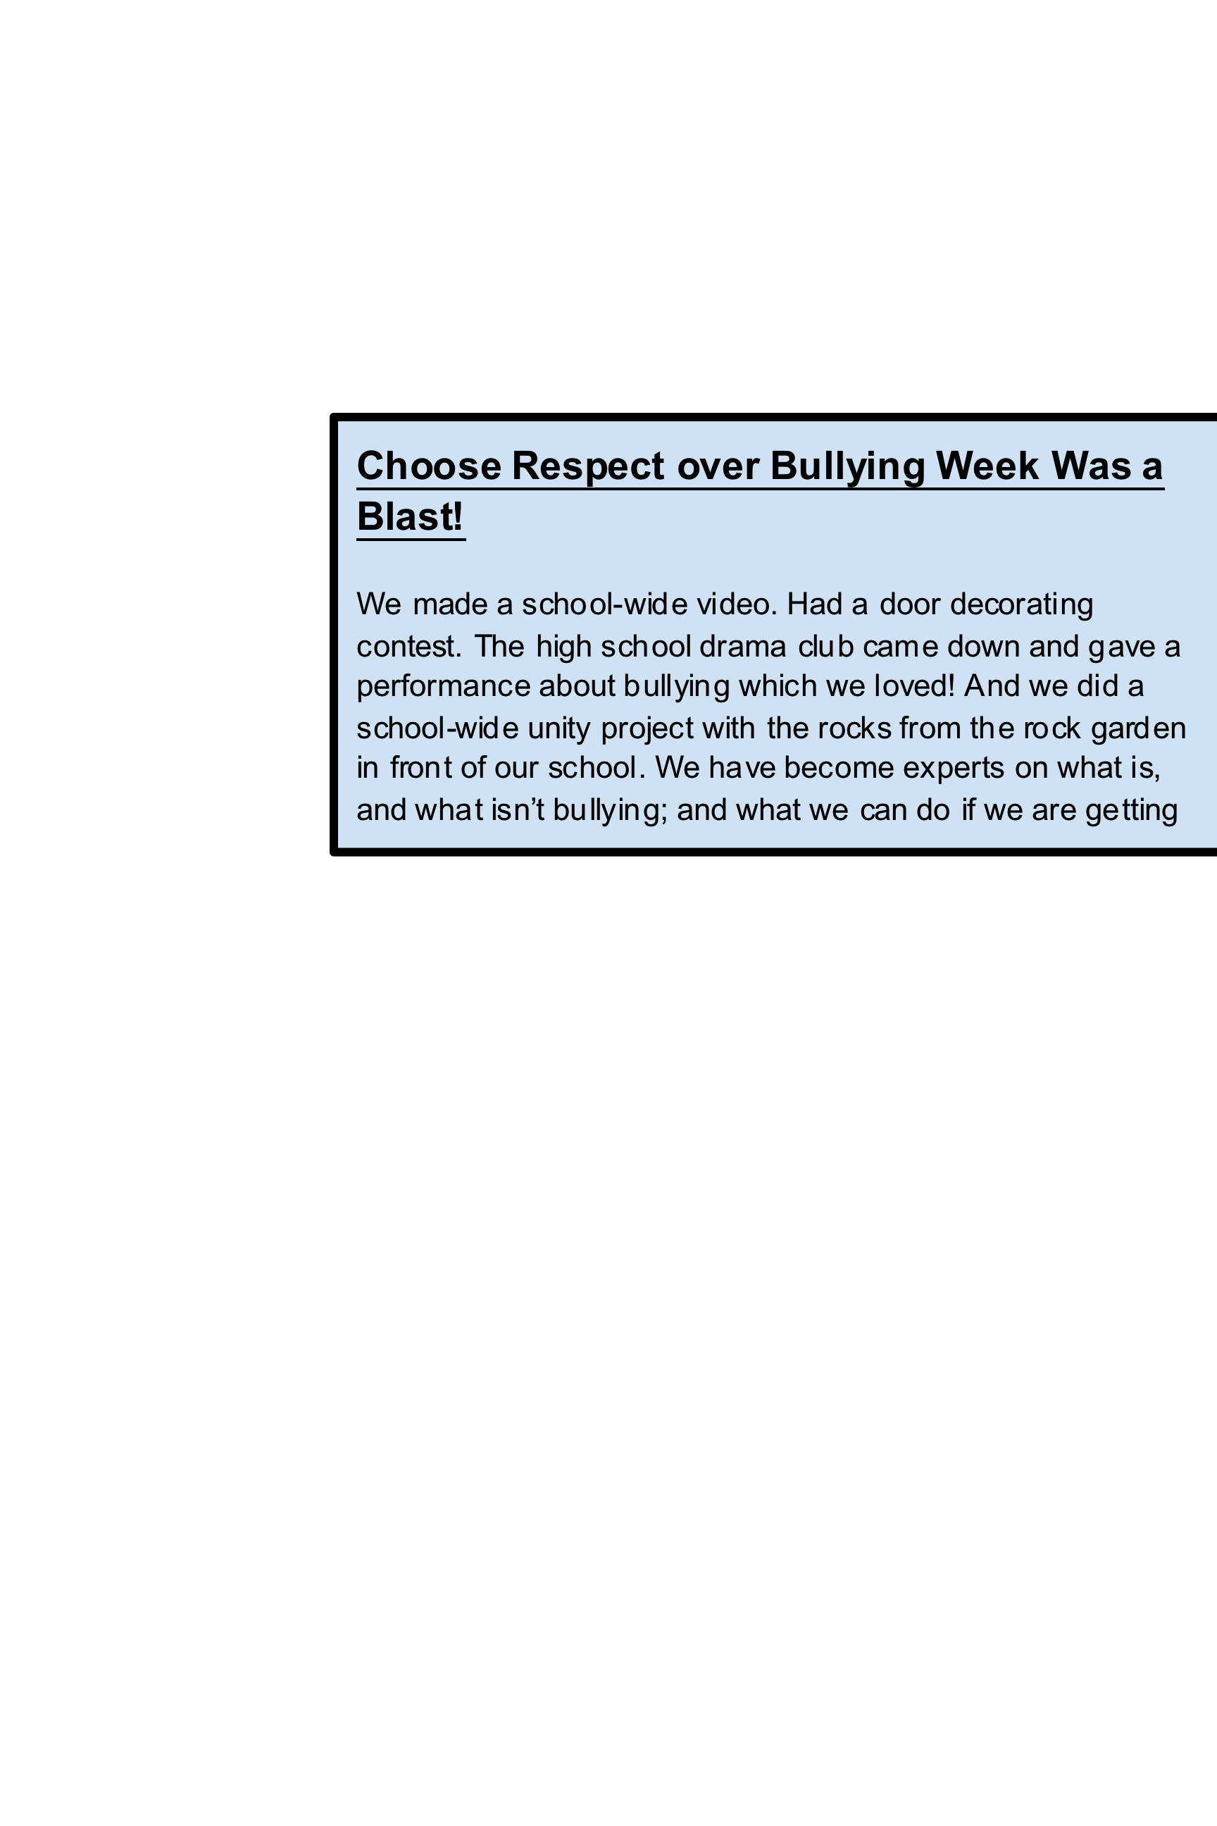

* Christmas Toy Drive
* Winter Clothing Drive
* Walter the Therapy Dog’s first day of school
* Bucket Filler Assembly

**Fall Fundraiser**

Thanks to everyone for your support in the Fall Fundraiser, our final numbers will be out soon!

**Conference Meals**

We are still looking for people to help us supply sides and deserts to the teachers at both the Elementary and High schools during conferences.  The PTO is providing the main meal but we would like to make sure they get a full meal.

**Box Tops**

Our box top collection has ended as well but you can send in your box tops anytime, the more you collect the more your child's class will have during the next collection time!

**PTO Project Help**

The PTO is looking for small, clean flat rocks for a craft we would like to do. Please collect them before the snow flies and leave them in the box in the office.

**FROM the NURSE**

As cold and flu season approach, please keep our illness policies in mind when determining whether or not to send your child to school:

* **Fever** - defined as a temperature of 100 degrees or higher. Student must be fever free for 24 hours, without the use of fever reducing medications such as tylenol or ibuprofen (advil, motrin)
* **Vomiting/diarrhea illness** - must be symptom free for 24 hours
* **Bacterial infection** such as strep throat/pink eye/impetigo - must be on antibiotics for 24 hours

We appreciate families following these policies to help reduce the spread of illness.  As always, remind your kids to cover their coughs and wash their hands!!

**UPCOMING EVENTS** – be sure to mark your calendars:

**November 5th** – Teacher workday; no school for students

**November 13th & 15th** – Conferences

**November 22 & 23** – Thanksgiving Break; No school

**December 7th** – Teacher PLC day; No school

**December 20th** – Holiday Program @6:00pm at BHS (please note time change)

**December 22nd-January 1st** – Winter Break

**January 2nd** – School Resumes

##### **PTO updates**