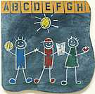

Leaps and Bounds Supply List

__ Copy of child’s CURRENT immunizations
__ backpack
__ 2 rolls of paper towel
__ 2 packs of disinfecting wipes
__ 1 heavy duty plastic folder (any color, any design)
__ 1 wide-ruled notebook (any color, any design)
__ 1 bottle of glue
__ 4 glue sticks
__ 1 pack washable markers
__ 1 pack of dry erase marker
__ set of extra clothes in a gallon size ziplock bag
__ water bottle

** Please only label the folder, notebook and water bottle.

