Supplies for Kindergarten
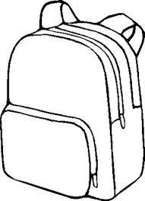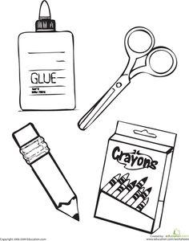

- 3-24 Count Boxes of Crayola Crayons
- 2-8 ct. Large Markers
- 1 Pack of Dry Erase Markers
- Large pack of glue sticks
- Watercolor Paints (8 color pack)
- 3 – 70 Count Wide Lined Spiral Notebook
- 2 – Sturdy Plastic Folders
- Plastic Pencil Box (8X5)
- Scissors
- $5.00 for classroom headphones
- Backpack or School Bag
- Pack of #2 Pencils (10)
- Pair of Tennis Shoes

**Items to send if you can: Sandwich or Gallon size Ziploc bags, disinfectant wipes.

Note: Your child does not need an extra pair of gym shoes. If they already own tennis shoes, they can use those. It is your choice if they will wear them to school or leave them at school.

